***Game Design Document***

***Fill up the following document***

1. ***Write the title of your project.***

***Tappu Ji***

1. ***What is the goal of the game?***

***The name of goal is palace and the player has to reach the palace.***

1. ***Write a brief story of your game.***

***There will be a player inside the game and there will be many obstacles out of which some will be small obstacles and some will be big obstacles If the player touches the small obstacles then one life of the player will be lost.There will be 3 lives inside the game and 5 chance will be given if the player hits the small obstacle then he will get 100 points and he will also get feedback.If the player touches the big obstacle then all the three lives of the player will be lost simultaneously and If the player hits the big obstacle then a window will open there.In which there will be an entertaining multiple choice question, if the player answers it correctly then he will get 100 points and then he will also get feedback and if the player gives wrong answer then he will lose one life.The timer inside the game will also be of 300 seconds, when the window opens, then the game time will stop and the time of 15 seconds will start for the question in the window.There will also be a goal inside the game. There will be a big palace in the ball, when the player reaches the goal, the player will go inside the palace and go to the first terrace and wave the flag of India and when the flag of India is waved, the crackers animation will start***

***and player will come to pick up the helicopter.Animated greeting card will show when player enters the palace.player will go to the next level by helicopter.There will also be a checkpoint inside the game, whenever the player is out after crossing the checkpoint, the player will start the game in the next life from the same checkpoint.There will also be stones in the game, the obstacle will come out of the stone again and again and will also go back in.If the player touches the stone obstacle, the player's a life will end.There will also be coins inside the game. Coins will be hidden behind the block, when the player jumps under the block, the coin will come out. When the player takes the coin, the player will get 50 points.Breaking the empty blocks will get 20 points, some of the blocks will produce flowers, When the player takes flowers, he will get bullets, the player can hit any obstacle with the bullet.If the player loses 3 lives, then one chance will also be lost and if 5 chances are exhausted then it will take 20 minutes to get a chance.The player will be able to hit the smaller obstacle by jumping once and the larger obstacle by jumping twice.When the player does not reach before the end of time, all three lives of the player will be lost.***

***.***

1. ***Which are the playing characters of this game?***

* ***Playing characters are the ones who respond to the user based on the input from the user.***
* ***Cars, monkeys, dinos, wizards, etc., are the playing characters in the game.***

|  |  |  |
| --- | --- | --- |
| ***Number*** | ***Character Name*** | ***What can this character do?*** |
| ***1*** | ***Player / tappu*** | ***He is main characters of this game. He play the game. He want to reach to the goal.*** |

1. ***Which are the Non-Playing Characters of this game?***

* ***Non-Playing characters are the ones that don't have an action or behavior when the user interacts with the game.***
* ***Hurdles, stones, bananas, coins, etc., are non-playing characters in the game.***

|  |  |  |
| --- | --- | --- |
| ***Number*** | ***Character Name*** | ***What can this character do?*** |
| ***1*** | ***Small obstacle*** | ***It will stand as an obstacle in front of the player.will not allow the player to reach the goal.*** |
| ***2*** | ***Big obstacle*** | ***It will stand as an obstacle in front of the player.will not allow the player to reach the goal.*** |
| ***3*** | ***Stone’s obstacle*** | ***It will stand as an obstacle in front of the player.will not allow the player to reach the goal.*** |
| ***4*** | ***Option*** | ***If option is write then player get more points and if option is wrong then one live of player is go off.*** |
| ***5*** | ***timer*** | ***Telling the player what time it is left.*** |
| ***6*** | ***points*** | ***Telling the player how many points have been scored*** |
| ***7*** | ***goal*** | ***cheering the player and giving a greeting card*** |
| ***8*** | ***block*** | ***The coin is hidden behind the block*** |

1. ***Draw your imagination of this game. What does this game look like?***

* ***Draw the game either on your computer or on paper.***
* ***Add images of the game scenes to show each of the playing and non-playing characters at least once.***

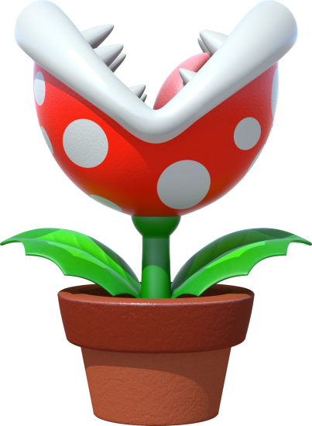 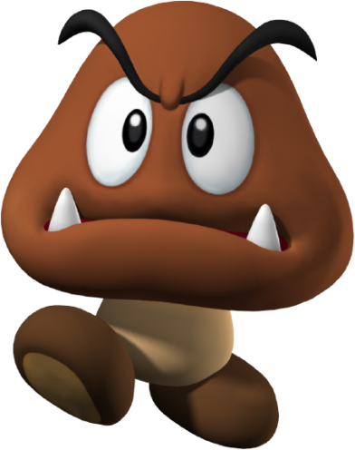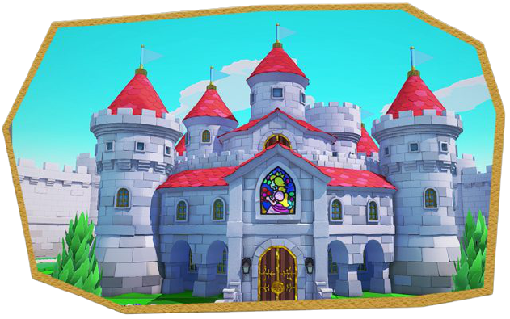

1. ***How do you plan to make your game engaging?***

***If the player hits the big obstacle then a window will open there.In which there will be an entertaining multiple choice question, if the player answers it correctly then he will get 100 points and then he will also get feedback . when the player reaches the goal, the player will go inside the palace and go to the first terrace and wave the flag of India and when the flag of India is waved, the crackers animation will start and player will come to pick up the helicopter.Animated greeting card will show when player enters the palace.player will go to the next level by helicopter.***